## Geometric Modeling

Project 6

Name: Rahul Kumar Nalubandhu

Email id: [nalubanr@oregonstate.edu](mailto:nalubanr@oregonstate.edu)

Output:

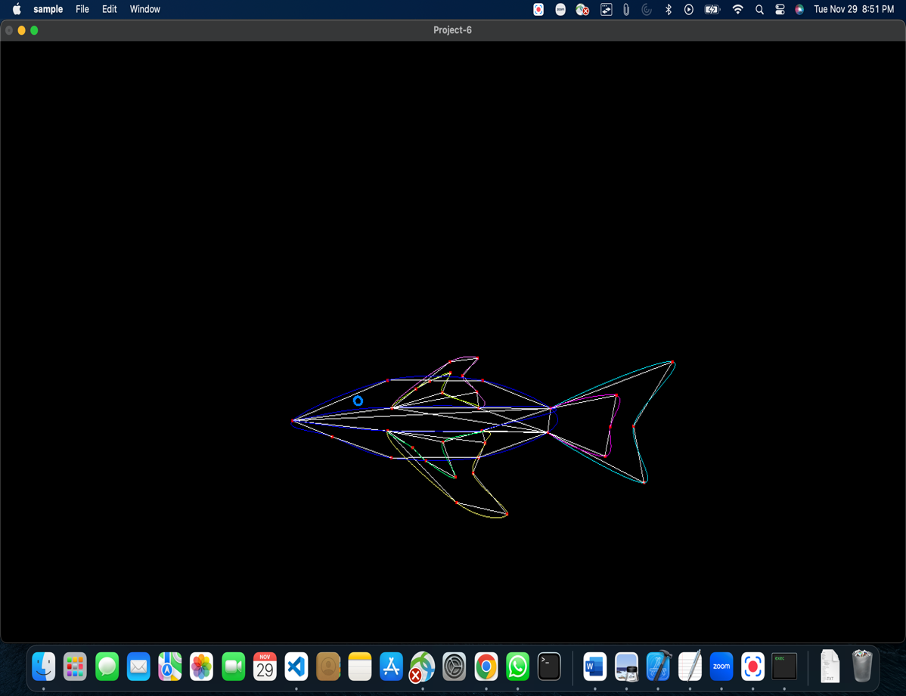 🡪control points, lines, and curves

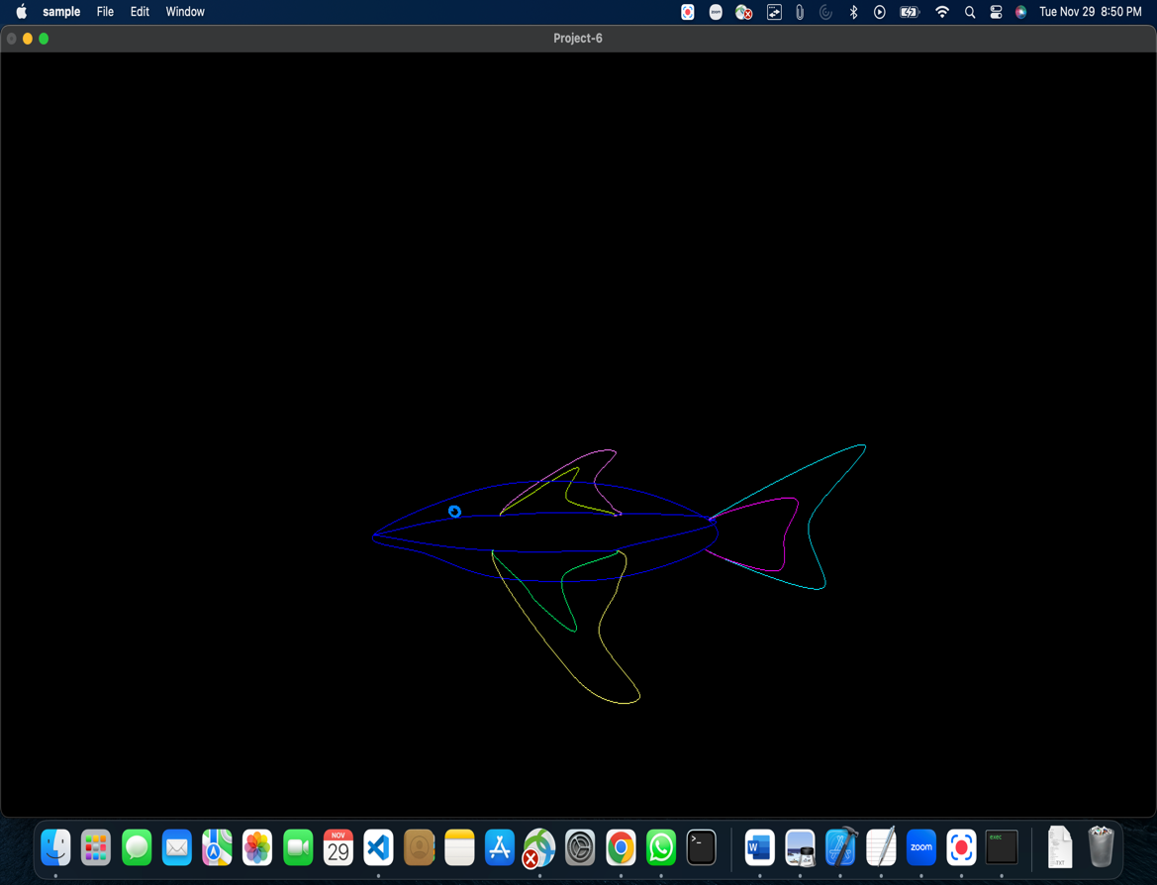 🡪curves

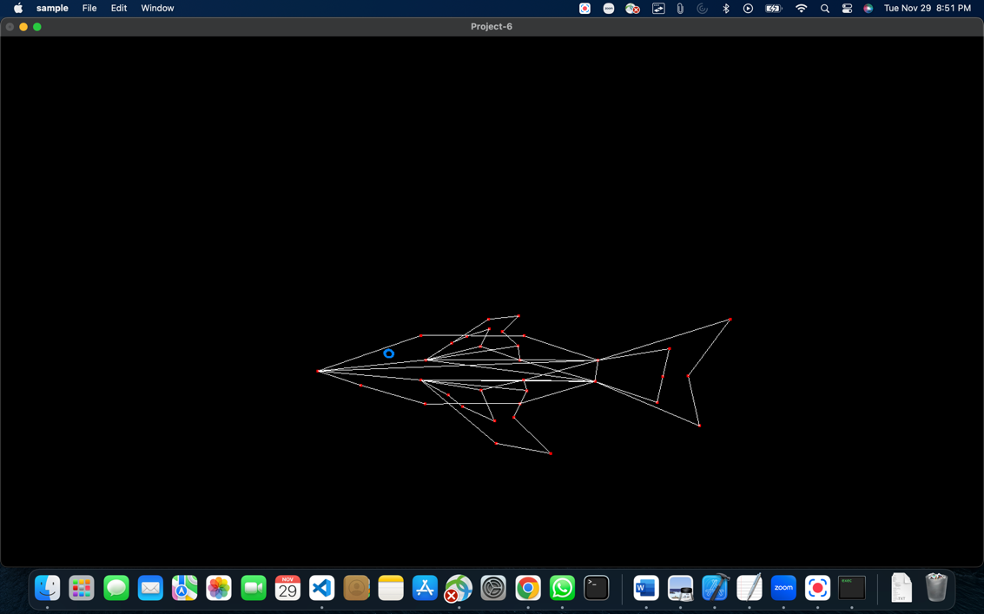🡪 control points and lines

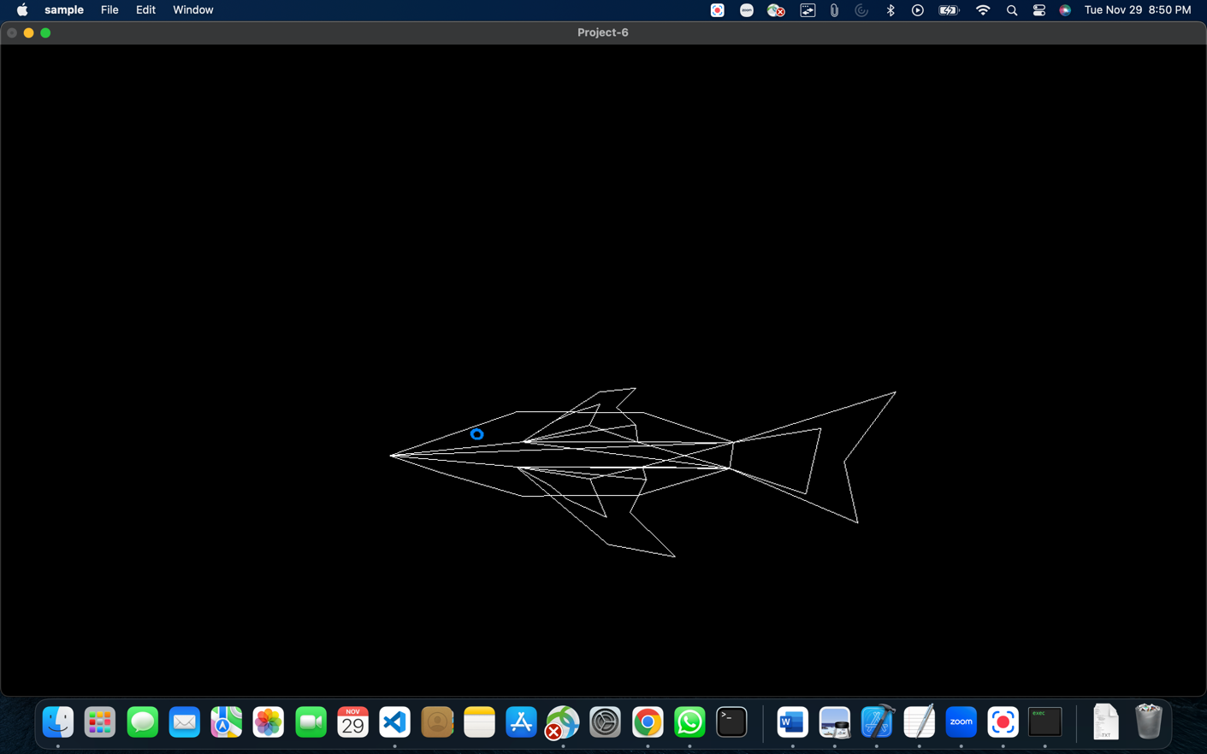🡪 control lines

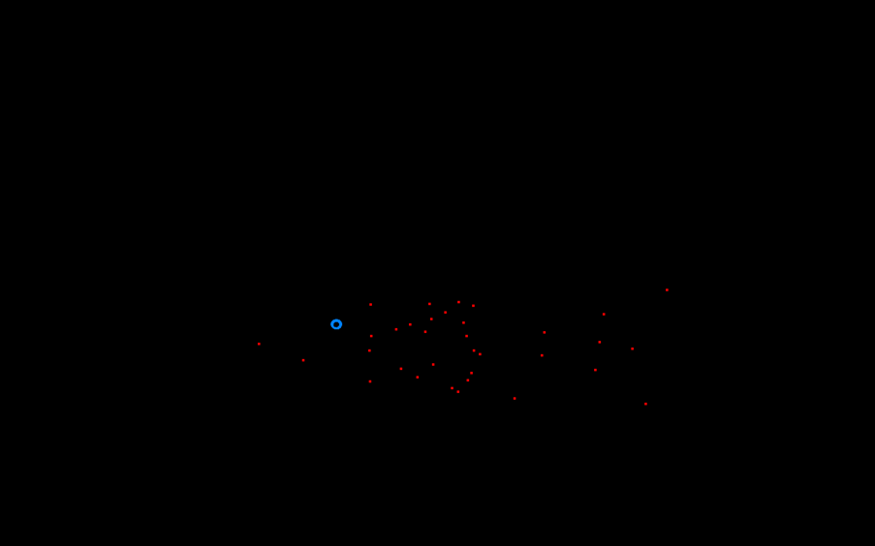🡪 control points

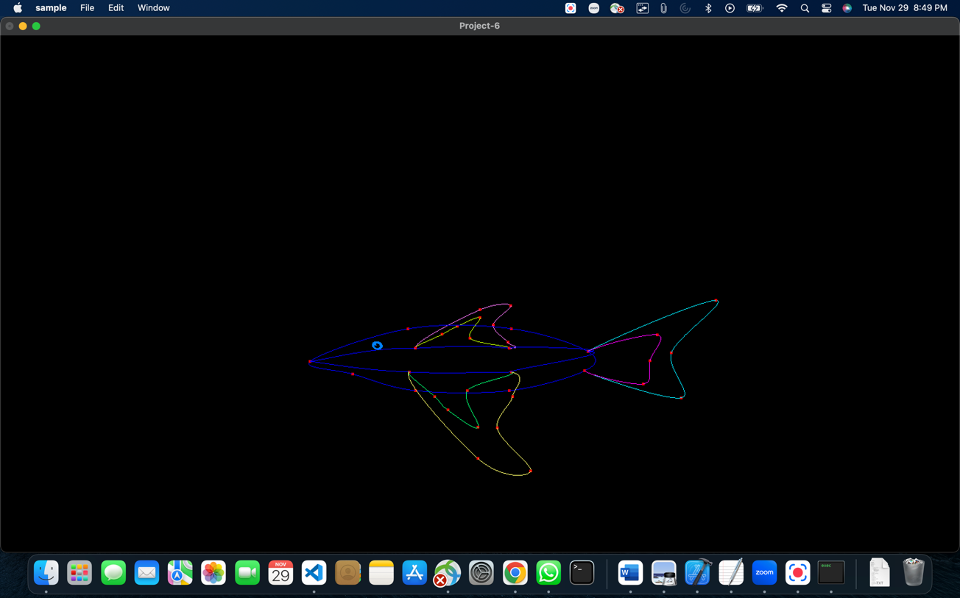 🡪 curves and points

I have used one stationary 3D curve i.e., the shark body and more than 6 animated curves.

I have the option to turn control points (d or D) and control lines (l or L) and curves(c, C) on and off.

Vídeo link: <https://media.oregonstate.edu/media/t/1_es5n8dph>